**Name – Akshat Jaiswal**

**Roll No. – 21052646**

**Section – CSE 37**

**DSA LAB 5**

1. **WAP to create a linked list (three nodes) and print it.**

**Input:**

#include <stdio.h>

*struct* Node{

*int* data;

*struct* Node *link;

};

*int* main (*void*){

*struct* Node N1,N2,N3;

*struct* Node *Head;

    Head=&N1;

    N1.data=10;

    N1.link=&N2;

    N2.data=20;

    N2.link=&N3;

    N3.data=30;

    N3.link=NULL;

*struct* Node *ptr;

    ptr=Head;

     while(ptr!=NULL){

        printf("%d  ",ptr->data);

        ptr=ptr->link;

     }

return 0;

}

**Output:**

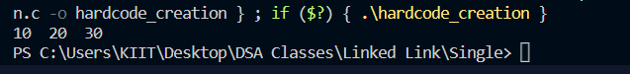

1. **WAP to create a linked list and print it (dynamically)**

**Input:**

#include <stdio.h>

#include <stdlib.h>

*struct* Node

{

*int* data;

*struct* Node *next;

};

*int* main (*void*){

*struct* Node *Head;

*struct* Node *New;

*struct* Node *ptr;

*char* choice;

Head=NULL;

New=(*struct* Node*)malloc(sizeof(*struct* Node));

printf("Enter a value: ");

scanf("%d",&New->data);

fflush(stdin);

New->next=NULL;

Head=New;

ptr=Head;

printf("\nDo you want to add another Node?\n\n(Y/N): ");

scanf("%c",&choice);

while(choice=='Y' || choice =='y'){

New=(*struct* Node*)malloc(sizeof(*struct* Node));

printf("Enter a value: ");

scanf("%d",&New->data);

fflush(stdin);

New->next=NULL;

ptr->next=New;

ptr=ptr->next;

printf("\nDo you want to add another Node?\n\n(Y/N): ");

scanf("%c",&choice);

}

if(choice=='N' || choice=='n')

printf("\nOkay, your choice pal..");

ptr=Head;

*int* count=0;

while (ptr!=NULL)

{

    count++;

    ptr=ptr->next;

}

printf("\nNumber of Nodes: %d",count);

return 0;

}

**Output:**

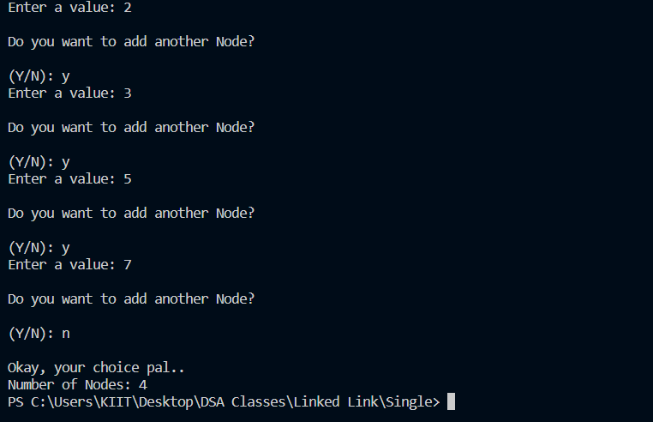

1. **WAP to create a LL and print its alternate nodes.**

**Input:**

#include <stdio.h>

#include <stdlib.h>

*struct* Node

{

*int* data;

*struct* Node *next;

};

*int* main (*void*){

*struct* Node *Head;

*struct* Node *New;

*struct* Node *ptr;

*char* choice;

Head=NULL;

New=(*struct* Node*)malloc(sizeof(*struct* Node));

printf("Enter a value: ");

scanf("%d",&New->data);

fflush(stdin);

New->next=NULL;

Head=New;

ptr=Head;

printf("\nDo you want to add another Node?\n\n(Y/N): ");

scanf("%c",&choice);

while(choice=='Y' || choice =='y'){

New=(*struct* Node*)malloc(sizeof(*struct* Node));

printf("Enter a value: ");

scanf("%d",&New->data);

fflush(stdin);

New->next=NULL;

ptr->next=New;

ptr=ptr->next;

printf("\nDo you want to add another Node?\n\n(Y/N): ");

scanf("%c",&choice);

}

ptr=Head;

*int* count=0;

while (ptr!=NULL)

{

    printf("%d  ",ptr->data);

    ptr=(ptr->next)->next;

}

ptr=Head;

while(ptr!=NULL){

    count++;

    ptr=ptr->next;

}

printf("\nNumber of Nodes: %d",count);

return 0;

}

**Output:**

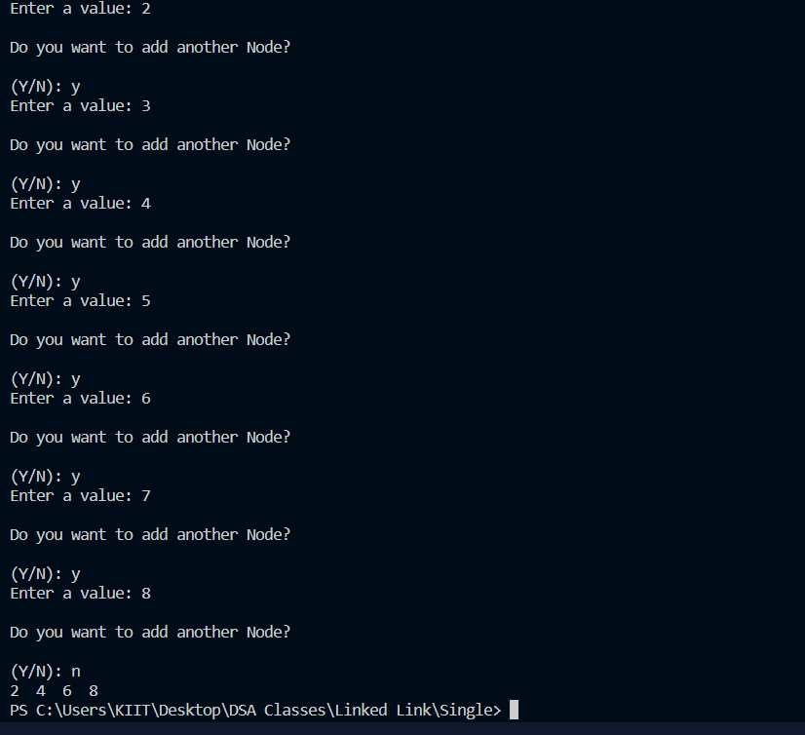

1. **WAP to Create a linked list and insert a new node as per the user’s choice.**

**Input:**

#include <stdio.h>

#include <stdlib.h>

*struct* Node

{

*int* data;

*struct* Node *Link;

};

*int* main (*void*){

*struct* Node *Head;

*struct* Node *New;

*struct* Node *PTR;

Head=NULL;

New=(*struct* Node*)malloc(sizeof(*struct* Node));

printf("Enter the value: ");

scanf("%d",&New->data);

fflush(stdin);

New->Link=NULL;

Head=New;

PTR=Head;

*char* choice;

printf("Do you want to create another node\n\n(Y/N): ");

scanf("%c",&choice);

fflush(stdin);

while(choice=='Y' || choice=='y') {

New=(*struct* Node*)malloc(sizeof(*struct* Node));

printf("Enter the value: ");

scanf("%d",&New->data);

fflush(stdin);

New->Link=NULL;

PTR->Link=New;

PTR=PTR->Link;

printf("Do you want to create another node\n\n(Y/N): ");

scanf("%c",&choice);

fflush(stdin);

}

PTR=Head;

while(PTR!=NULL){

    printf("%d  ",PTR->data);

    PTR=PTR->Link;

}

*int* pos;

printf("\nEnter the postion you want to insert a node: ");

scanf("%d",&pos);

insert_specific_point(&Head,&pos);

PTR=Head;

while(PTR!=NULL){

    printf("%d  ",PTR->data);

    PTR=PTR->Link;

}

return 0;

}

*void* insert_specific_point(*struct* Node \*\**Head*,*int* \**pos*){

*struct* Node *New;

*struct* Node *PTR;

    New=(*struct* Node*)malloc(sizeof(*struct* Node));

    if(New == NULL)

    {

        printf("\nMemory Not Available!\n");

        exit(0);

    }

    else{

    printf("\nEnter the value of New Node to be inserted at the postion: ");

    scanf("%d",&New->data);

*int* count=0;

    PTR=\**Head*;

    while(count < \**pos*-1){

        count++;

    PTR=PTR->Link;

    }

    New->Link=PTR->Link;

    PTR->Link=New;

    }

}

**Output:**

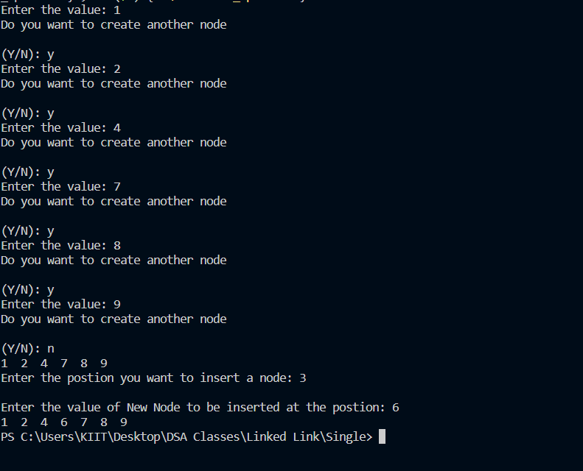

1. **WAP to create a linked list and delete a new node as per the user’s choice**

**Input:**

#include <stdio.h>

#include <stdlib.h>

*struct* Node

{

*int* data;

*struct* Node *Link;

};

*int* main (*void*){

*struct* Node *Head;

*struct* Node *New;

*struct* Node *PTR;

Head=NULL;

New=(*struct* Node*)malloc(sizeof(*struct* Node));

printf("Enter the value: ");

scanf("%d",&New->data);

fflush(stdin);

New->Link=NULL;

Head=New;

PTR=Head;

*char* choice;

printf("Do you want to create another node\n\n(Y/N): ");

scanf("%c",&choice);

fflush(stdin);

while(choice=='Y' || choice=='y') {

New=(*struct* Node*)malloc(sizeof(*struct* Node));

printf("Enter the value: ");

scanf("%d",&New->data);

fflush(stdin);

New->Link=NULL;

PTR->Link=New;

PTR=PTR->Link;

printf("Do you want to create another node\n\n(Y/N): ");

scanf("%c",&choice);

fflush(stdin);

}

PTR=Head;

while(PTR!=NULL){

    printf("%d  ",PTR->data);

    PTR=PTR->Link;

}

*int* pos;

printf("\nEnter the postion you want to delete a node: ");

scanf("%d",&pos);

delete_specific_point(&Head,pos);

PTR=Head;

while(PTR!=NULL){

    printf("%d  ",PTR->data);

    PTR=PTR->Link;

}

return 0;

}

*void* delete_specific_point(*struct* Node \*\**Head*,*int* *pos*){

*struct* Node *PTR,*TEMP;

*int* count=0;

    PTR=\**Head*;

    while(count < *pos*-1){

        count++;

    PTR=PTR->Link;

    }

    TEMP=PTR->Link;

    PTR->Link=TEMP->Link;

    free(TEMP);

    }

**Output:**

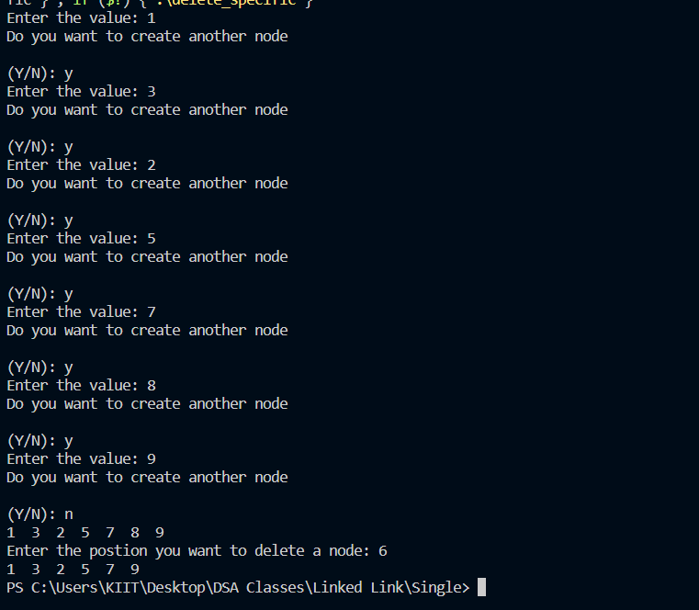

1. **WAP to create a circular link list and print all the elements.**

**Input:**

#include <stdio.h>

#include <stdlib.h>

*struct* Node

{

*int* data;

*struct* Node *next;

};

*void* traversal(*struct* Node \*\**head*)

{

*struct* Node *ptr;

    ptr = \**head*;

    printf("The Linked List: ");

    while (ptr->next != \**head*)

    {

        printf("%d  ", ptr->data);

        ptr = ptr->next;

    };

    printf("%d  ", ptr->data);

    ptr = ptr->next;

    printf("%d  ", ptr->data);

}

*int* main(*void*)

{

*struct* Node *head, *ptr, *new;

*char* choice;

    // Allocate memory for nodes in the linked list in Heap

    new = (*struct* Node *)malloc(sizeof(*struct* Node));

    head = NULL;

    // Link first and second nodes

    printf("Enter first node value: ");

    scanf("%d", &new->data);

    fflush(stdin);

    new->next = NULL;

    head = new;

    ptr = head;

    printf("\nDo you want to add another Node?\n\n(Y/N): ");

    scanf("%c", &choice);

    while (choice == 'Y' || choice == 'y')

    {

        new = (*struct* Node *)malloc(sizeof(*struct* Node));

        printf("Enter a value: ");

        scanf("%d", &new->data);

        fflush(stdin);

        new->next = NULL;

        ptr->next = new;

        ptr = ptr->next;

        printf("\nDo you want to add another Node?\n\n(Y/N): ");

        scanf("%c", &choice);

        if (choice == 'N' || choice == 'n')

            ptr->next = head;

    }

    traversal(&head);

    return 0;

}

**Output:**

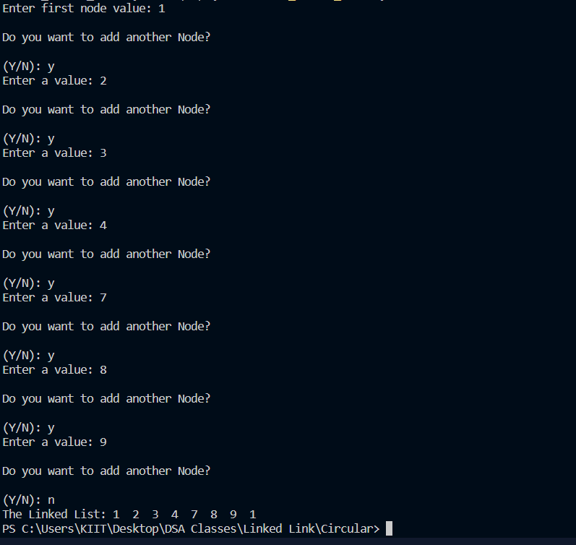

1. **WAP to create a linked list and perform linear search**

**Input:**

#include <stdio.h>

#include <stdlib.h>

*struct* Node

{

*int* data;

*struct* Node *Link;

};

*int* main (*void*){

*struct* Node *Head;

*struct* Node *New;

*struct* Node *PTR;

Head=NULL;

New=(*struct* Node*)malloc(sizeof(*struct* Node));

printf("Enter the value: ");

scanf("%d",&New->data);

fflush(stdin);

New->Link=NULL;

Head=New;

PTR=Head;

*char* choice;

printf("Do you want to create another node\n\n(Y/N): ");

scanf("%c",&choice);

fflush(stdin);

while(choice=='Y' || choice=='y') {

New=(*struct* Node*)malloc(sizeof(*struct* Node));

printf("Enter the value: ");

scanf("%d",&New->data);

fflush(stdin);

New->Link=NULL;

PTR->Link=New;

PTR=PTR->Link;

printf("Do you want to create another node\n\n(Y/N): ");

scanf("%c",&choice);

fflush(stdin);

}

*int* count=0;

PTR=Head;

while(PTR!=NULL){

    count++;

    PTR=PTR->Link;

}

printf("The Number of Nodes: %d",count);

*int* key,flag=0;

printf("\nEnter key: ");

scanf("%d",&key);

PTR=Head;

while(PTR!=NULL){

    if(PTR->data==key)

    flag=1;

    PTR=PTR->Link;

}

if (flag==1)

printf("\nSearch Successfull! ");

else

printf("\nSearch NOT Successfull! ");

return 0;

}

**Output:**

